**PROJECT DOCUMENTATION**

1. BACKGROUND

Learner’s Academy is a school that has an online management system. The system keeps track of its classes, subjects, students, and teachers. It has a back-office application with a single administrator login.

1. PROJECT GOAL

To develop a prototype of the application.

The goal of the company is to deliver a high-end quality product as early as possible.

1. SPRINT PLANNING

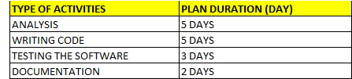

Refer to attached Appendix A for detail Sprint planning.

1. TOOLS

The prototype of the application will be develop by using the JAVA programming language, HTML, JDBC, Servlet and JSP and the IDE will be Eclipse.

1. CONCEPT

As mentioned above, the Java programming will be deployed to develop the protype of the application.

Among the concept involved in the project are as following:

* Java OOP programming
* Database Management System
* JDBC
* Servlet
* JSP

1. FUNCTIONALITIES

The generic features and the operations are as following:

* A master list of all the subjects for all the classes
* A master list of all the teachers
* A master list of all the classes
* Assign classes for subjects from the master list
* Assign teachers to a class for a subject (A teacher can be assigned to different classes for different subjects)
* A master list of students (Each student must be assigned to a single class)

1. FLOW CHART

Refer to the Appendix 1 attached.

1. FINAL WORD

The project is merely a prototype of the application.

Further input from the relevant stakeholder is highly sought to improve the relevant feature and functionalities of the software.

*** END ***